**POTATO BLIGHT**

GBC has declared there is an infestation of Potato Blight at Brockhurst and Middlecroft Allotment sites. It is likely other sites will be affected before too long.  You are encouraged to check your potato plants.  There is a difference between blight infected plants and those that are dying back ready for harvesting.  If you have blight then it is best to cut the haulms (stems) off the plant at ground level and dispose in accordance with the instructions on the gate (copy below).  Doing this should help protect the potatoes underground so you may still get something edible to harvest.

Tomatoes, especially outdoor grown, are also susceptible to blight and this normally appears as black splotches on the stem and on fruit.  If you have some infected plants and not others then be careful touching non-infected plants after touching infected plants.

**BLIGHT**

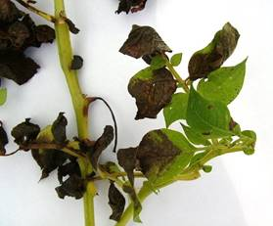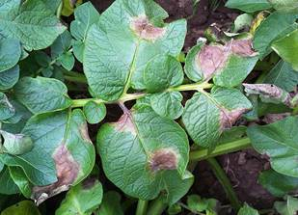

**DYING BACK FOR HARVESTING**

