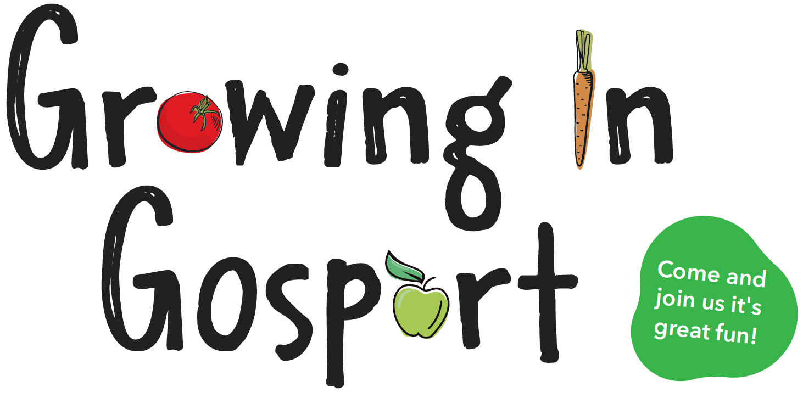

Do you, or someone you know, want learn how to grow your own vegetables?

The ‘Growing in Gosport’ Project run by Gosport Allotment Association has been developed to help show people how to grow their own vegetables.

The sessions take place Saturday mornings
between 10am to 12 Noon at Brockhurst Allotment Site.

The best thing is, you get to keep and eat the food that you grow on a mini-allotment plot. As waiting lists are lengthy on most allotment sites then why not join this scheme to gain experience before moving on to a plot of your own.

If you’re interested in joining us on Saturday mornings, starting soon then please get in touch through our website www.gosportallotments.co.uk or scan the QR code below.
Or you can visit one of our allotment stores, which are open mostly Sunday mornings.

